What is Node Js?
- An free and open source server environment.
- Javascript can be used on server.
- A single language for both FRONTEND(CLIENT SIDE) and backend(Server Side)

NPM-> It facilitate us to install packages
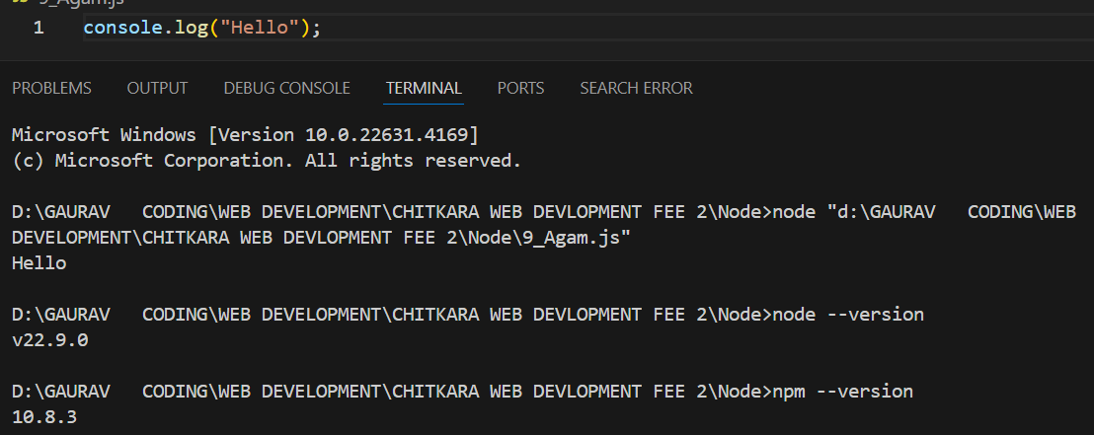
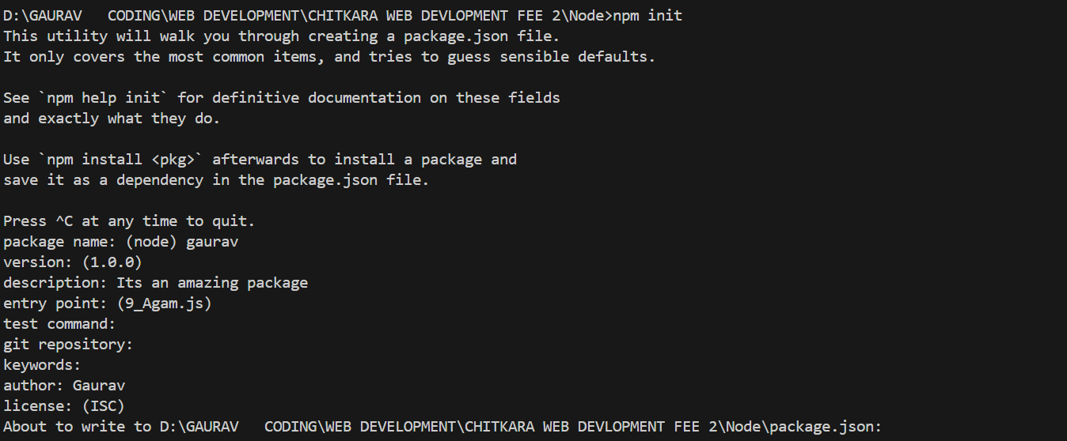
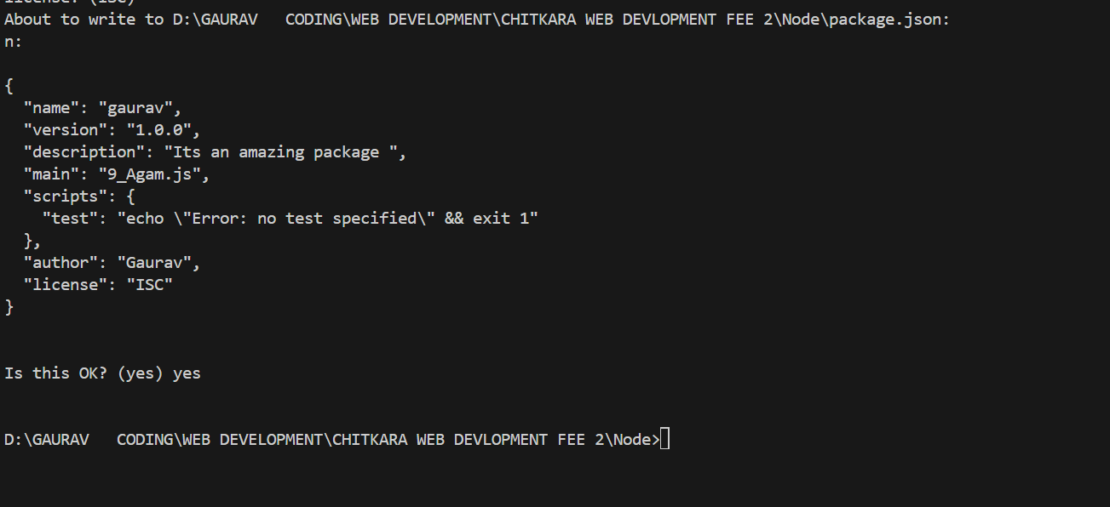

Express Install:
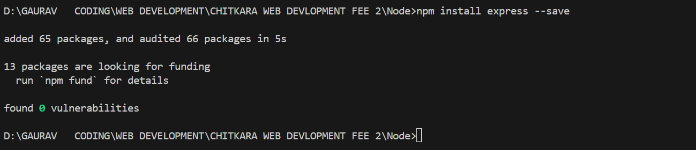
AT 10.4 TO Show server to Global Clients
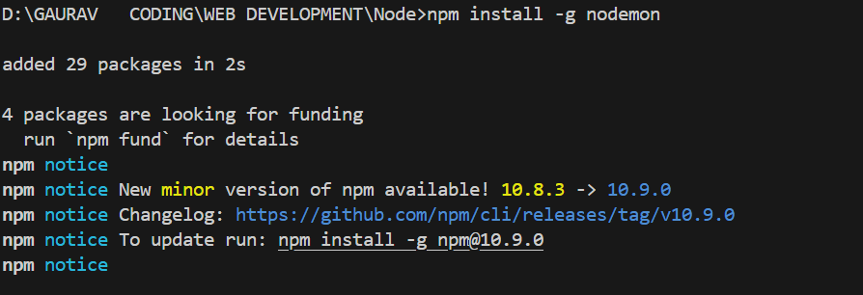

Install Express
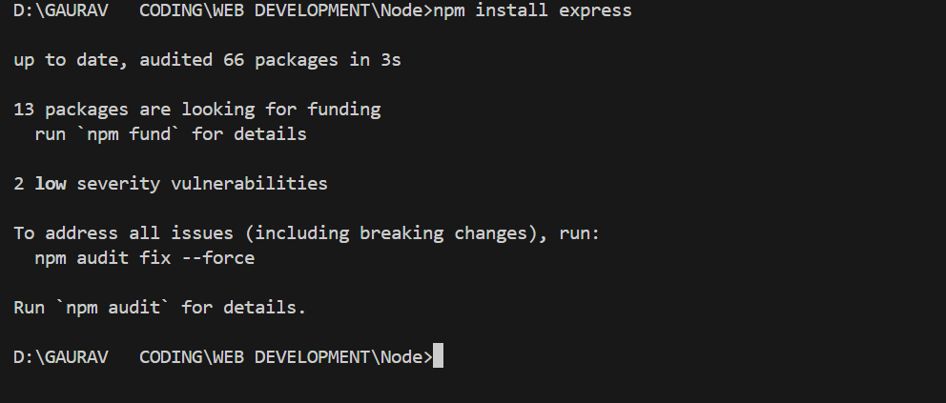
Nodemon ON Express.js
